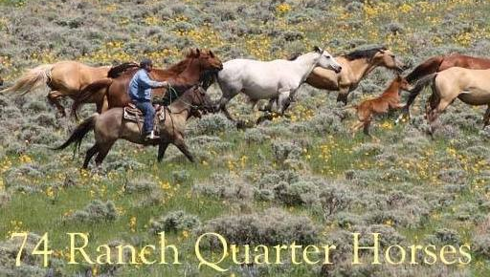
Deposit and Holding Agreement for 74 Ranch Foal/Horse

The following agreement is between Tom and/or Garrett Herbst/74 Ranch, breeders, and ____________________________, purchaser. This deposit of $500 shows good faith that you will be purchasing the foal/horse _____________________________________
_________. The deposit is applied toward the full purchase price of $_______. If more than 1 foal is being purchased, the deposit is $400 each. Please list any other foals you plan to acquire below and the full amount agreed upon $ ____________ :

NOTE: Foal sells on AQHA Breeder’s Certificate/Registration Application & Signed Transfer. Foal can stay at the ranch until November 10th free of charge. Full payment is required at that time. After that, board will be charged at a rate of $5/day. Seller will use reasonable means to ensure health & safety of the weaned foal, but buyer will be responsible for any veterinary or farrier care required while board is being charged. Initial deposit is non-refundable and will be retained by the Seller if the Buyer changes his/her mind and decides not to purchase foal/horse at any time prior to pick-up. This deposit will be refunded to Buyer if foal dies or is seriously injured prior to weaning or may be transferred to another available or future foal. Seller will provide current negative coggins, health paperwork for traveling and brand inspection.
Deposit may be made by check, money order or cash. Final payment must be cash or money order.
Purchaser(s) signature ____________________________________ Date ______________

Purchaser(s) Names: __________________________________________________________

Address: ________________________________________________________________

Phone: ___________________ Cell: _______________ Email: ___________________

Breeder’s Signature: _____________________________________ Date: _______________
74 Ranch 6121 Road 38 Torrington WY 82240 307-534-6579 or 307-575-5225

